# **Jenkins Manual Approval**

Create Jenkins pipeline

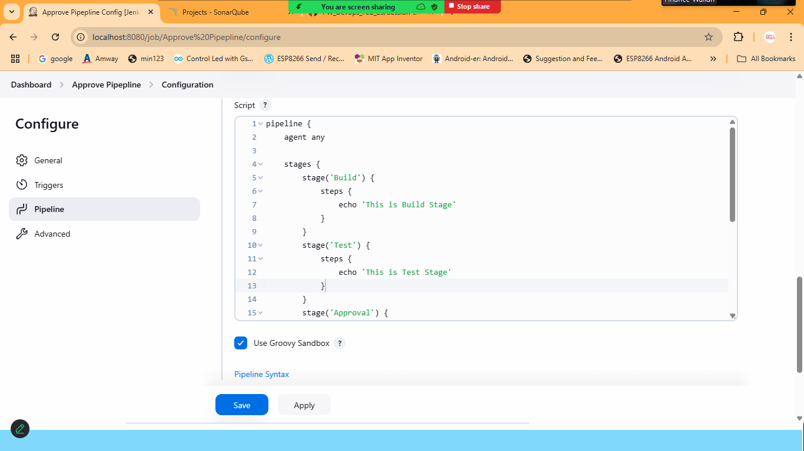

pipeline {

agent any

stages {

stage('Build') {

steps {

echo 'This is Build Stage'

}

}

stage('Test') {

steps {

echo 'This is Test Stage'

}

}

stage('Approval') {

steps {

timeout(time:15,unit:"MINUTES"){

input message:'Do you Want to Approve the Deployment?',ok:'yes'

}

}

}

stage('deployment') {

steps {

echo 'App Deployed'

}

}

}

}

Save and Build Now

Check the console output

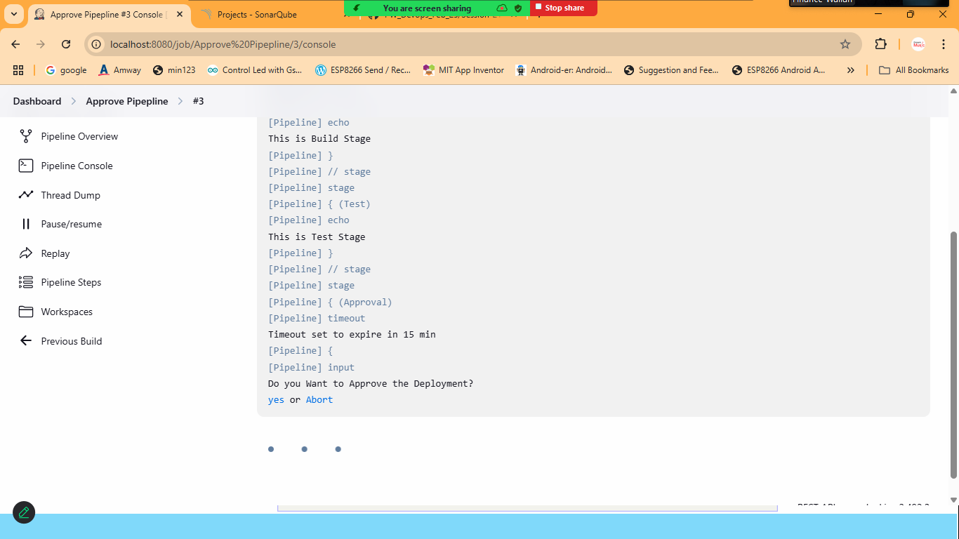

Click on yes to approve or abort to cancel

If the option is not selected it will abort after given time

# **PIPELINE-2**

## (Jenkins + Email + Manual Approval )

Step:1 SMTP Configuration ,must be done

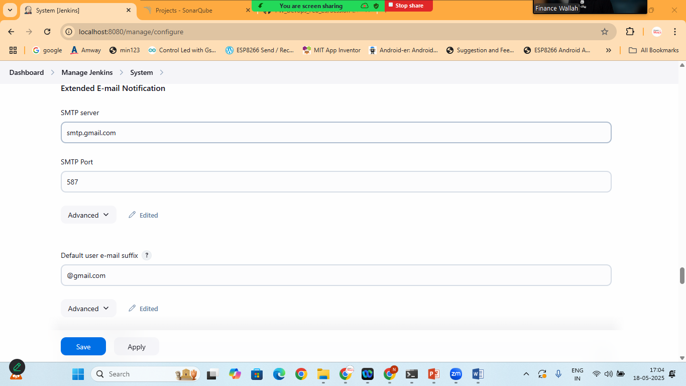

Create new Jenkins Pipeline

pipeline {

agent any

stages {

stage('Build') {

steps {

echo 'Build successful'

}

}

stage('Test') {

steps {

echo 'Tests passed'

}

}

stage('Email for Approval') {

steps {

mail to: 'youremail@gmail.com',

subject: "Approval Needed for Production Deployment",

body: """\

Build #${env.BUILD_NUMBER} is ready for approval.

Click the following link to approve:

${env.BUILD_URL}

Login and click "Proceed" in the "Approval" stage.

"""

}

}

stage('Approval') {

steps {

timeout(time: 10, unit: 'MINUTES') {

input message: "Do you approve the production deployment?", ok: "Approve"

}

}

}

stage('Deploy to Production') {

steps {

echo 'Deploying to production...'

}

}

}

}

Email:

